HOW TO USE THIS TEMPLATE (delete this box before submission)
This template is built entirely on Word Styles (Home ▸ Styles). Apply a style instead of formatting by hand, and just overtype the placeholder text.
Body paragraphs use the Normal style; section headings use Heading 1 / 2 / 3 (keep the numbers, e.g. “2.1 …”). Keeping this structure lets us auto-convert the paper to JATS-XML for J-STAGE and indexing.
References follow APA 7th edition (author–date). List alphabetically; cite in text as (Author, Year).
Insert equations with Word’s equation editor (Insert ▸ Equation). Number them at the right margin.
Figures/photos: ≥300 dpi (vector preferred); cite every figure and table in the text before it appears.

Title of the Manuscript: Concise, Specific, and Informative
Taro Tanaka¹, Heng Zhang² and John Smith³*
¹ Dept. of Civil Engineering, University of Doboku, Tokyo, Japan
² Doboku Corporation, Tokyo, Japan
³ Institute of Industrial Science, The University of Tokyo, Tokyo, Japan
* Corresponding author: smith@example.ac.jp · ORCID 0000-0000-0000-0000
Abstract
Provide a single-paragraph abstract of at most 300 words. State the problem, the approach, the principal results (quantified where possible), and the main conclusion. Do not use citations, footnotes, or undefined abbreviations. The abstract must stand alone, because indexing services (J-STAGE, Scopus, Web of Science) display it apart from the full text.
Keywords: deep learning, infrastructure maintenance, digital twin, structural health monitoring, data science (3–6 terms, comma-separated)
Highlights
- State 3–5 bullet points, each ≤ 85 characters including spaces.
- Convey the core findings and their novelty at a glance.
- Avoid abbreviations and detailed numbers here.

1. Introduction
State the background, the gap in existing knowledge, and the objective of the study. Use author–date citations throughout, e.g. recent reviews chart the rapid uptake of AI in civil engineering (Chun, 2023), and the transformer architecture (Vaswani et al., 2017) underpins many current models. Close the introduction with an explicit statement of contributions.
A second paragraph is indented on its first line and carries no extra space above it — the convention used by most journals, including Automation in Construction and Computer-Aided Civil and Infrastructure Engineering. This keeps the column dense and easy to read.

2. Materials and Methods
Describe data, models, and procedures in enough detail to allow replication. Define every symbol and abbreviation at first use.

2.1 Study area and data
Describe the dataset, its provenance, and any preprocessing. Cite datasets like any other source (Ministry of Land, Infrastructure, Transport and Tourism, n.d.).

2.2 Model architecture
Present the proposed method. Refer to display items by label: the configuration is summarised in Table 1, and the training behaviour is shown in Fig. 1(a).

a) Implementation details
Use Heading 3 for sub-sub-sections. Report hyper-parameters, hardware, and software versions. A displayed, numbered equation looks like:
ŷ = f( Σᵢ wᵢ xᵢ + b ) (1)

3. Results
Report findings objectively and quantitatively, referring to each display item. Reserve interpretation for the Discussion. As shown in Fig. 1, the proposed model converges faster and attains higher accuracy than the baseline; per-metric scores are listed in Table 1.
Table 1. Model performance on the held-out test set. Place the caption above the table.
Model | Accuracy | Precision | Recall
Baseline CNN | 0.91 | 0.90 | 0.89
Proposed | 0.96 | 0.95 | 0.96

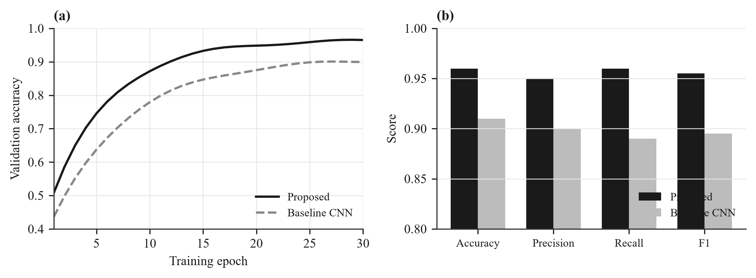
Fig. 1. Sample placeholder figure — replace with your own. (a) Validation accuracy versus training epoch; (b) per-metric comparison. Use panel labels (a), (b) for composite figures and cite them as Fig. 1(a). The caption goes below the figure.

4. Discussion
Interpret the results against prior work, state the limitations, and explain the practical and scientific significance.

5. Conclusions
Summarise the main findings and their implications, and outline future work.

Author Contributions
Use CRediT roles, e.g. T. Tanaka: conceptualization, methodology, writing — original draft; H. Zhang: software, validation; J. Smith: supervision, writing — review and editing. All authors have read and agreed to the published version of the manuscript.

Funding
State all funding and grant numbers, e.g. “This work was supported by JSPS KAKENHI Grant Number XXXXXXXX.” If none: “This research received no external funding.”

Data Availability Statement
State where the supporting data reside, e.g. “The data are openly available in [repository] at https://doi.org/XXXX.” If data cannot be shared, explain why.

Conflicts of Interest
Declare competing interests. If none: “The authors declare no conflict of interest.”

Acknowledgments
Acknowledge non-funding support. Disclose any use of generative-AI tools here, as required by the journal’s publication-ethics policy.

References
Chun, P. J. (2023). AI in civil engineering: A roadmap for research and development. Artificial Intelligence and Data Science, 4(1), 1–10. https://doi.org/10.11532/XXXXXXX
Goodfellow, I., Bengio, Y., & Courville, A. (2016). Deep learning. MIT Press.
Izumi, S., & Chun, P. J. (2024). Low-cost training data creation for crack detection using an attention mechanism in deep learning. Intelligence, Informatics and Infrastructure, 5(1), 1–12. https://doi.org/10.11532/XXXXXXX
Ministry of Land, Infrastructure, Transport and Tourism. (n.d.). Road structure database [Data set]. Retrieved January 1, 2026, from https://road-structures-db.mlit.go.jp/
Vaswani, A., Shazeer, N., Parmar, N., Uszkoreit, J., Jones, L., Gomez, A. N., Kaiser, Ł., & Polosukhin, I. (2017). Attention is all you need. In Advances in Neural Information Processing Systems (Vol. 30, pp. 5998–6008). Curran Associates.

(Received Month DD, 20XX; accepted Month DD, 20XX)

